Sub 合并当前目录下所有工作簿的全部工作表()   
Dim MyPath, MyName, AWbName Dim Wb As Workbook, WbN As String   
Dim G As Long   
Dim Num As Long   
Dim BOX As String   
Application.ScreenUpdating = False   
MyPath = ActiveWorkbook.Path   
MyName = Dir(MyPath & "\" & "*.xls")   
AWbName = ActiveWorkbook.Name   
Num = 0   
Do While MyName <> ""   
If MyName <> AWbName Then   
Set Wb = Workbooks.Open(MyPath & "\" & MyName)   
Num = Num + 1   
With Workbooks(1).ActiveSheet   
.Cells(.Range("A65536").End(xlUp).Row + 2, 1) = Left(MyName, Len(MyName) - 4)   
For G = 1 To Sheets.Count   
Wb.Sheets(G).UsedRange.Copy .Cells(.Range("A65536").End(xlUp).Row + 1, 1)   
Next   
WbN = WbN & Chr(13) & Wb.Name   
Wb.Close False   
End With   
End If   
MyName = Dir   
Loop   
Range("A1").Select   
Application.ScreenUpdating = True   
MsgBox "共合并了" & Num & "个工作薄下的全部工作表。如下：" & Chr(13) & WbN, vbInformation, "提示"   
End Sub

**操作步骤：**

1. **新建一个文件夹，把需要合并的表格都放到新建的文件夹内**
2. **在新建文件夹内新建一个EXCEL表格**
3. **打开新建的EXCEL空表格，按ALT+F11，选择“插入-模块”如图**： 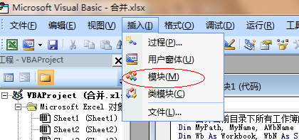

**在模块内复制上面代码，如图：**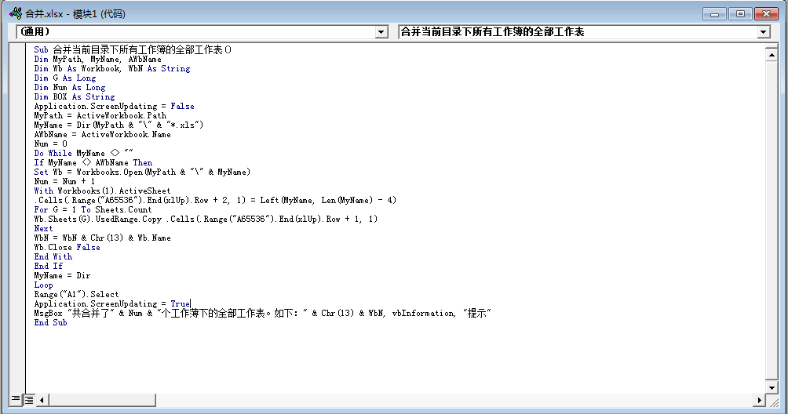

1. **点击上面选项“运行”**

如图：

1. **运行结果**

**合并前**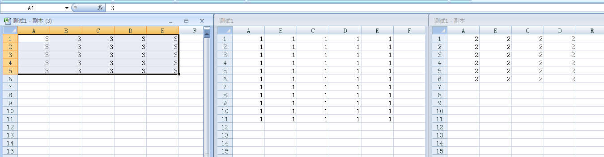

**合并后**：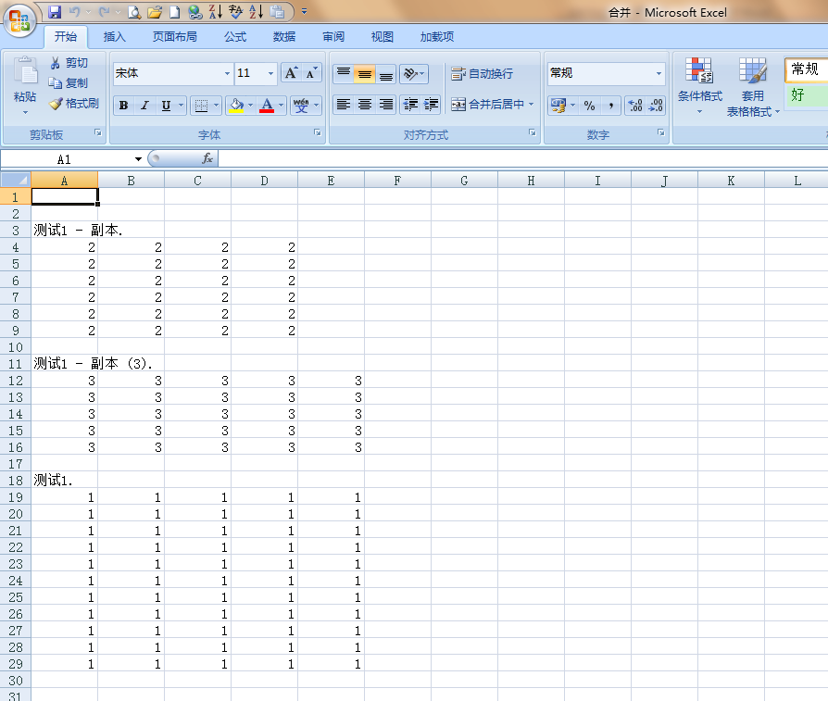

**合并内容**

